**Level 1: PC Tower Case**

**Outline**

Learn about the internals of a standard PC case by examining physical samples and selecting and labeling images found on-line. Gain deeper knowledge by researching and reporting on specific components.

**Questions**

1. Find one (or more) images that clearly show the internals of a PC Tower Case.   
   (i.e. Google images using keywords “PC Case Internals”)  
   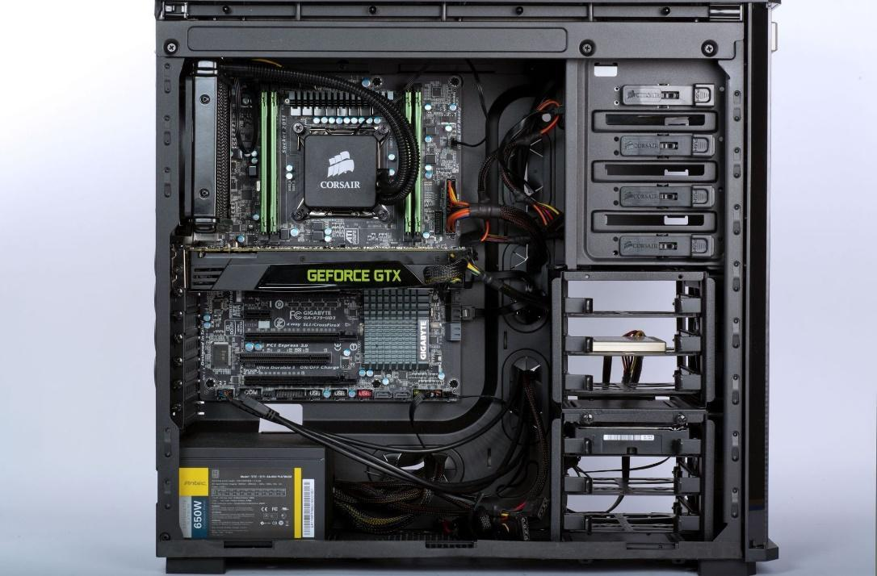

1. Clearly label the following components (using arrows) on your image of the PC case internals:
   1. Motherboard
      1. Power Supply
         1. Hard Disk Drive
            1. Optical Disk Drive (e.g.DVD)

USB Expansion Ports

Monitor Port

* 1. Audio Ports
     1. Ethernet Port
        1. Cooling Fan

1. Research more in-depth about “Motherboards”. Make notes on the following:
   1. What different versions are currently available (speed and capacity)

* **GIGABYTE X470 AORUS Ultra Gaming Socket AMD AM4 X470 Chipset Dual Channel DDR4, PCI-E 3.0, SATA 6.0Gb/s, M.2 USB 3.0 Motherboard**

# ASUS ROG Strix Z390-E Gaming Motherboard LGA1151 (Intel 8th and 9th Gen) ATX DDR4 DP HDMI M.2 USB 3.1 Gen2 Onboard 802.11ac WiFi

# ASRock B450 PRO4 Socket AM4 Dual Channel, PCIe 3.0, 2xM.2 USB 3.1, DP, HDMI, D-Sub, RGB ATX Motherboard

* 1. How the component has changed since the 1980’s

**Component has changed by the improvement of each component in a motherboard. Their improvement made a huge different in the gaming world with the improved speed and capacity in a motherboard.**

1. Research more in-depth about “Hard Disk Drives”. Make notes on the following:
   1. What different versions are currently available (speed and capacity)

### **Best hard drive: Seagate Barracuda Interface: SATA 6Gbps | Capacity: 2 – 3TB | Cache: 64MB | RPM: 7,200**

### **Best high capacity hard drive: Toshiba X300 Interface: SATA 6Gbps | Capacity: 4 – 8TB | Cache: 128MB | RPM: 7,200**

### **Best gaming hard drive: WD VelociRaptor Interface: SATA 6Gbps | Capacity: 250GB – 1TB | Cache: 64MB | RPM: 10,000**

* 1. How the component has changed since the 1980’s  
       
     **Hard Disk Drives had changed over time with the speed, capacity, and RPM. The differences between the old Hard Disk Drives and the new 2019 Hard Disk Drives is the increase of many thing in a Hard Disk Drives.**

**NOTE:**

* Download the on-line version of this module (from the class GitHub repository)
* Questions for Level 2 and Level 3 are in the on-line version of this module
* Provide your answers in a MS Word, PowerPoint, or equivalent format
* Upload your answers to your personal GitHub repository

**Level 2: PC Motherboard**

**Outline**

Learn about the structure of a standard PC motherboard by examining physical samples and selecting and labeling images found on-line. Gain deeper knowledge by researching and reporting on specific components.

**Questions**

1. Find one (or more) images that clearly show the layout of a PC Motherboard.   
   (i.e. Google images using keywords “PC Motherboard”)

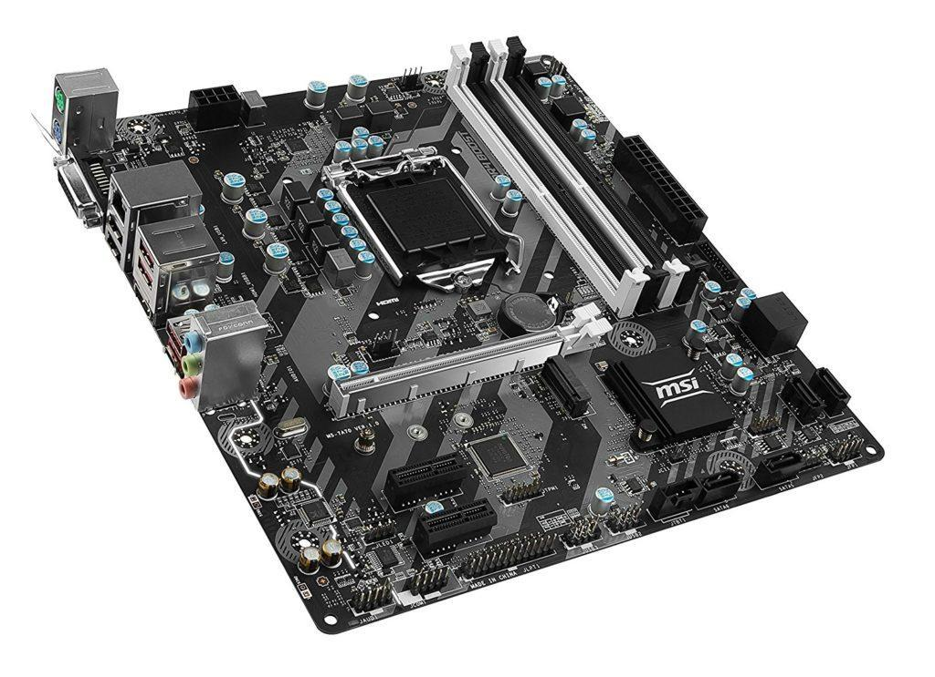

1. Clearly label the following components (using arrows) on your image of the PC motherboard:
   1. CPU (and fan)
      1. RAM Memory
         1. Disk Drive Interface (IDE or SATA)
            1. GPU Graphics Processor (either on-board or Graphics Card)

Sound Processor (either on-board or Sound Card)

Wi-Fi / Ethernet Network Interface (either on-board or Graphics Card)

1. Research more in-depth about “CPU Processor Chip”. Make notes on the following:
   1. What different versions are currently available (speed and capacity)

* **AMD Ryzen 7 2700X speed: 4.3GHz capacity:16MB**
* **Intel Core i9-9900K speed:5.0GHz capacity:16MB**
* **Intel Pentium G4560 speed:3.5GHz capacity:3MB**

* 1. How the component has changed since the 1980’s

**Back in the 1980’s CPU’s were such bigger than the CPU we know now. They didn't have the best speed, capacity, etc. The prices between 1980’s and 2019 is very different because the prices in 2019 are like $300-$500 and in 1980 the prices were lower than that of the CPU in 1980.**

1. Research more in-depth about “RAM Memory”. Make notes on the following:
   1. What different versions are currently available (speed and capacity)

* **Patriot Viper Steel DDR4-4400 (2x8GB) Capacity: 16 GB (2x 8GB)**
* **Corsair Vengeance RGB Capacity 32GB (4x 8GB)**
* **G.Skill Trident Z DDR4-3000 Capacity 32GB (2x16)**
  1. How the component has changed since the 1980’s  
     **Back in the 1980’s RAM Memory didn’t have the best speed and capacity. Also something like 4-5MB were somewhat a lot. the prices were also different because the prices in 1980 were $150 to $250.**

**Level 3: Peripheral Devices**

**Outline**

Learn about how peripheral devices are connected to the back side of a typical PC tower case. Examine physical samples, select and labeling images found on-line and gain deeper knowledge by researching and reporting on specific components.

**Questions**

1. Find one (or more) images that clearly show the layout of the back of a typical PC tower case.   
   (i.e. Google images using keywords “Back Of PC Tower”)  
   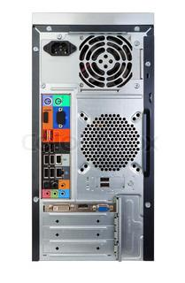  
   
2. Clearly label the following components (using arrows) on your image of the back of a typical PC tower case:
   1. Power cord and power switch
      1. Monitor Interface (VGA or DVI or HDMI)
         1. Mouse Interface (USB or PS/2)
            1. Keyboard Interface (USB or PS/2)

USB Ports

Audio Inputs / Outputs

Ethernet Interface

1. Research more in-depth about “Monitor Technology”. Make notes on the following:
   1. **What different versions are currently available (e.g. VGA / DVI, Flat Panel Technology))**

* **BenQ PD3200U Screen size: 32-inch | Aspect ratio: 16:9 | Resolution: 3,840 x 2,160**
* **AOC Agon AG352UCG6 Black Edition Screen size: 35-inch | Aspect ratio: 21:9 | Resolution: 3,440 x 1,440**
* **Asus ROG Swift PG27UQ Screen size: 27-inch | Aspect ratio: 16:9 | Resolution: 3,840 x 2,160**

1. Research more in-depth about “External Portable Storage”. Make notes on the following:
   1. Floppy Disks

* **Floppy Disks were made in 1970.**
* **Floppy Disks devices are used to read and write storage info**.
  1. CD-ROM / DVD / Recordable
* **CD-ROM / DVD / Recordable are used for storage.**
* **CD-ROM speed range**
  1. USB Memory Drives
* **USB allow anyone to access the information on the USB.**
* **The newest USB can be around 1 to 2TB**
  1. Compact Flash Memory
* **Compact Flash Memory are used for storing music and pictures.**
* **Type III is the best one between Type II and Type I. It has a better size and storage, but it costs more.** 
  1. Cloud Based Storage
* **A Cloud Based Storage is like google drive to store your things.**
* **You don't need to pay for storing these things.**

**Level 4: PC Component Presentation**

**Outline**

Explore the development and features of a specific PC hardware component through deeper research and investigation. Work in partners to create a short presentation. Deliver the presentation to the class.

Each group will research a unique PC hardware component . Your specific topic will be assigned from the list provided below.

**Presentation Structure**

1. Explain what the PC component does and how it fits together with other components to make up a fully functioning PC.
2. Explain how the PC component works. Provide a diagram (image) showing the main parts of the component.
3. Research the current state of the art of the component in terms speed, capacity (size), and other related factors.
4. Research on-line suppliers that sell the PC Component. List the specifications for the available products and the cost (price).
5. Research how the PC component has changed and evolved since the early days of PCs in the 1980’s. Cover each of the following topics separately:
   1. Component Speed
   2. Component Size / Capacity
   3. Two other specifications specific to the PC component (ask Mr. Nestor)

**PC Component Topics**

|  |  |  |
| --- | --- | --- |
| **Topic** | **Partner 1** | **Partner 2** |
| CPU Microprocessor Chip |  |  |
| Motherboard Layout |  |  |
| Computer Graphics |  |  |
| Sound & Audio |  |  |
| Hard Disk Drives |  |  |
| Removable Disk Storage |  |  |
| Network / Internet Connectivity |  |  |
| Mouse / Pointing Devices |  |  |
| Monitor & Display Technology |  |  |
| Printers & Output Technology |  |  |